project title:
SMART ECO SYSTEM
TEAM:
Dorota Marczak, Scott Allan, Nader Sobhi
Outline Business Case & project plan
Version Number: 1.0
Version Date: 20.09.2018

DDNS Ltd., an information technology company located at Abertay University, DD1 1HG Dundee, is pleased to provide this IT Project Proposal to Lynsay Shepherd, the CEO of Abertay Plant System with the headquarter in Dundee.
By the signature of DDNS Ltd. authorized representative hereunder, this IT Project proposal constitutes a formal offer to provide the deliverables described on the terms and conditions described herein.
VERSION HISTORY

Version  Number | Implemented  By | Revision  Date | Approved  By | Approval  Date | Description of  Change
1.0 | Whole team | 09/20/18 | Dorota Marczak | 09/20/18 | The executive summary
1.1 | Dorota Marczak & Scott Allan | 09/27/18 | Dorota Marczak | 09/27/18 | The introduction
1.2

TABLE OF CONTENTS
1 Executive Summary 5
2 Introduction [from here you will be mainly looking at steps 1-3 from the stepwise planning approach discussed in the lecture; answering the questions discussed for each step will help with filling in sections 2-6 of the Proposal Template.] 6
2.1 Purpose of this Document 6
3 gENERAL Project iNFORMATION 6
3.1 Project Description 6
4 High-level Business Impact 7
5 aLTERNATIVES and aNALYSIs 8
6 Preferred Solution 8
6.1 Preliminary Work Breakdown Structure 8
6.2 Assumptions and Constraints 9
7 Detailed PROJECT PLAN [Here you will be mainly looking at steps 4 and ownards from the stepwise planning approach] 9
7.1 Product Breakdown Structure (a visual aid) 9
7.2 Activity Plan (a visual aid) 9
7.3 Resource Allocation and Timeline 9
7.4 Identification of Critical Path 9
7.5 Identification of Costs and Benefits 10
7.6 Justification of Project Approach & Project Methodology 10
7.7 Version Control and Requirements Changes 10
7.8 Quality Assurance and Test Plan 10
7.9 Risk Management Plan 10
8 References 11
Appendix A: Approval 12
Appendix B: Key Terms 14
Appendix C: Team Rules and Roles 15
Appendix D: Minutes & Reflection 16
Appendix E: Peer Assessment 17
Appendix F: Artefact or prototype material 18

1 Executive Summary
The client, Lynsay Shepherd, representing Abertay Plant System, has identified the need for a Plant Monitoring System that will be commercially produced. The purpose of this device will be to monitor the light, temperature, humidity and moisture levels of any given plant. DDNS Ltd., an IT firm proficient in designing and implementing IoT and smart technologies, have been tasked with developing a system that meets this goal. The system requested should also meet a number of secondary goals, which are defined as follows. Firstly, the solution should be effective, reliable and low-cost. Secondly, the system should be controlled remotely via a user-friendly web portal. The web portal should also be able to communicate the needs of the plants to the user, such as if the temperature is too hot or the light level too low. Thirdly, the system should produce useable data and clear statistics that will aid in optimizing the plant’s environment. Finally, the system should be fully documented to ensure clear terms of operation.
Aim of the Project
The client defined the optimization of the plants’ growth as the main goal of the project. This goal will be achieved by combining the vegetation and horticultural knowledge of Abertay Plant System with the cutting-edge system delivered by DDNS Ltd. The final product is expected to perform measurements and record environmental factors (temperature, light level, humidity & soil moisture level), which then will be stored in a relational database and displayed via a bespoke web portal.
Development process – Methodology
-DEFINE METHODOLOGY
The development process will begin with the team being acquainted with the requirements provided by the customer, which will then be followed by client consultations. This will help to clarify the mental model of the future product. The project will be developed in regular collaboration with the client, as this is a critical part of the chosen development methodology. In addition, the workflow will be easy to control via an online application providing flexibility of teamwork.
At every iteration of the prototype, appropriate testing will take place and the feedback from the Project Owner will be requested. On completion, a member of the team will prepare a short report including client’s recommendations and requests, as well as any obstacles that were faced. The above process will be repeated until the final iteration of the device is developed.

Potential risks and backup plan
One of the most probable risks related to the project is delay in releasing a fully functioning product. However, the above risk will be minimalized by a rigid work organization structure and appropriate task decomposition. Another issue that may appear during the process is exceeding the budget. This risk, in turn, may be reduced by keeping track of all the necessary hardware and software components and implementing only those absolutely required. Finally yet importantly, the customer may change their mind and vastly redefine the requirements. To mitigate the above problem we will keep in constant communication with the client, as this will be a great way to make sure we are meeting the client requirements.
Performance indicators & success defining
The product should be available at all times, perform as required and maintain a high level of quality output
Availability = There should be no system downtime as this may significantly impact upon the health of the plant
Performance = The product should perform as expected and aim to exceed user expectations where possible
Quality = The product should produce high quality output consistently that is useful to the user. This should be easy to interpret and provide the user with sufficient feedback to make informed decisions

Mapping key performance indicators onto business objectives
The product should be available at all times, perform as required and maintain a high level of quality output
The user must have the ability to view the real-time status of the plant as well as historical data. This will be available through the web portal and must always be available. The user must also have the ability to view any data related to the plant based on a set of parameters that the user provides.

There should be no system downtime as this may significantly impact upon the health of the plant
In order to monitor the plant and ensure it stays in optimal health, the system must be operational at all times. This includes the Arduino sub-system, the database and the web portal.

The product should perform as expected and aim to exceed user expectations where possible
Success of the product depends largely on the user interacting with the system in an intuitive and meaningful manner. The product should provide relevant information that will aid in maintaining an optimal environment for the plant to thrive.
The product should produce high quality output consistently that is useful to the user. This should be easy to interpret and provide the user with sufficient feedback to make informed decisions
Information should be displayed in an intuitive and readable manner via the web portal. Sufficient data should be provided to the user in order to adequately convey the status of the plant’s health and allow them to determine whether they need to make any changes to the plant’s environment.

Benefits of selecting our company for the project include:
DDNS Ltd. are a talented team of IT specialists with a wide range of knowledge and key expertise in IoT and smart technologies. We are adept at providing cost-effective solutions that will satisfy the needs of the client. Throughout the design, development and implementation process, client collaboration plays a key role in addressing any concerns as well as making them emotionally invested in the product and keeping them up to date with current developments and features.
About DDNS
DDNS Ltd. is a leading provider of expert Smart Technologies to local businesses in Scotland. The company boasts to have served an ever-growing number of clients relying on our experience in the IT field and time-efficient work organization, which gives the ability to complete projects on time and within the customer’s budget.
Contact details:
- Dorota Marczak  Role: Project Manager & Application Developer  Telephone number: 01234567899  Email: email@email.com | - Nader Sobhi  Role: Application Developer  Telephone number: 01234567899  Email: email@email.com
- Scott Allan
Role: Application Developer
Telephone number: 01234567899
Email: email@email.com

Introduction

Purpose of this Document
The purpose of the document is to provide the justification for undertaking this project for Lynsay Shepherd, CEO of Abertay Plant System, based on estimated costs, benefits and risks.

Throughout the development process, DDNS Ltd. team focuses on optimizing the costs of the devices and tools it is working on while preparing and implementing prototypes of the product, placing functionality over design.
As a company with long-standing experience, DDNS Ltd. is aware of the importance of determining the projects viability. The above-mentioned assessment cannot be based solely on the project costs, but also on time performance, quality of the final product and team availability and mobilization.
To meet these requirements, the company undertakes all the steps required to deliver an optimized system. To start with, the database use is limited to working hours. By doing so, database service cost is reduced by approximately 65% and any potential data wastage is avoided. Moreover, the team members are not allowed to work than 8 hours a day due to health guidelines and will have all the necessary tools and facilities provided to complete the project.
In addition, the Project Leader constantly monitors the viability of the project, making sure the budget is not exceeded and the project is on the right track. The Project Leader is also responsible for calling team meetings twice a day to gather project updates, as well as keeping the client informed and helping them to actively participate in every stage of the project.

gENERAL Project iNFORMATION

Submission Date | 13 November 2016
Requested By | Lynsay Shepherd
Business Owner | Andrea Szymkowiak
Contact Info. | 1604779@uad.ac.uk, 01234567899
Project Name | Smart Eco System
Desired Start Date | 9 January 2018
Desired End Date | 18 April 2018

Project Description

Business Need
We were approached by Lynsay Shepherd, CEO and representative of Abertay Plant Systems. The company produces gardening accessories that can be purchased to aid in customers daily gardening needs. Their main business lies in creating these accessories and selling through various retailers. The company requested this project, as they wanted to expand their market into IoT devices and Smart Technologies, due to its surging popularity in recent years. The company also realized that there was a good opportunity to enter the market since the alternatives currently available to purchase are expensive and require custom hardware.
The project will address the clients desire to enter the market of IoT devices. This will be achieved by creating a prototype system to get an idea of how feasible the system would be on a commercial scale. In creating a prototype system, we will have created an IoT device as well as the accompanying website, and database in order to provide the client with a fully functioning system and template that they can then use to create a commercial line for their product.
Fortunately, the data that will be collected by the IoT device is not sensitive information that would have to be encrypted or stored with a great emphasis on security. However, it is still data that is collected in people’s homes over long periods, as the devices will have a very long uptime due to the nature of its operations. In order to make sure that the device is compliant with the GDPR and other data regulations, the user will have to accept the collection of data from their device when they use the web interface for the first time. If they choose not to accept the agreement then the device will delete the data that may have been collected while the device was idle and not collect any future data. The data that will be collected will also be clearly outlined to the user in the agreement. Another piece of legislation that needs to be considered are copyright laws, due to the fact that we are using third party software and hardware for the creation and development of this system. However, the software and hardware we are using is open source under the European Union Public License and the Arduino Privacy Policy clearly states that the sale and distribution is authorized if you are the creator of the source code and have purchased the devices legally.
Moving forward, the benefits of the creation of this system for the client will be the procurement of a device and accompanying software that will be available to them that will allow the following benefits to the client; They will have a prototype device that will be the template for the devices that they go on to produce. They will have the code that will can then be put onto all the devices they will produce in the future. They will have a website that will allow them and the users to monitor the plants well-being and growth. Due to all this, they will gain a reputation for creating functional and useful IoT devices, which are also inexpensive. They will also be able to integrate this product with their current business model of gardening equipment and tools.
Our relation to the client is through our University Course, as we are all students. There were reliable sources informing us that Lynsay Sheperd, a lecturer and part time entrepreneur, wanted to hire or ask a team of developers to create a device and accompanying system that would push Abertay Plant Systems into the IoT sector. Upon hearing this, we approached Lynsay as a group and asked if she would like us to undertake this project. Upon reaching an agreement, we were provided with a project brief that highlighted the basic operating procedures for the device. Our team is comprised of three individuals that are component with the different aspects of system design and development that the project calls for. When interacting with the client we try to make sure that the whole group is present and we try to make sure that everyone in the group gets a chance to talk to make sure that there is not just one person talking with the client. This leads to there not being one leader or boss when it comes to client communication.

Goals/Objectives
For a concise overview, the short-term, long-term, and operational goals will be outlined, as well as reiterating the objectives for our project in a more formal and expansive manner. We are considering that our short-term goals are the goals we have set out for completion within 12 months of undertaking the project, long-term goals will be the goals that we believe this project can achieve after the 12 month period. Operational goals are goals that ensure that the project can smoothly transition from accomplishing its short-term goals to advancing its long-term goals.
Short Term Goals
For the short-term aspect of the project we identified the following goals: We aim to deliver a presentation that will showcase why we as a development team are the best choice for the client in order to gain the product they want. During this presentation we will also outline some of the ways we aim to completely satisfy the client’s requirements for the project. After the presentation we will also create a project proposal that will contain a very detailed description of all the aspects and methods that will eventually make up the final product. Another goal we aim to complete in the short-term is developing a prototype device that will showcase the basic function of our device going forward, this will serve as a showcase for the capabilities of the final product. This also applies to the website as we will have to develop a basic web page to show the general layout the web app will have. The database will also have to be created in the short-term as both hardware device and the website will require the database to work properly. We will also assemble the various components of the system to make sure that they can all work together. Part of this assembly process will include testing the various parts used for the hardware this will be done during the assembly process as it would be the most efficient way to test all the components.
Long Term Goals
The long-term goals of this project will encompass the short term goals and try to expand upon them enough that the client will be satisfied even after our involvement with the project is over. One of our long-term goals of ours is to provide the client with products and components that will be secure going forward. This means providing a website that will have security features in place, to try and mitigate attacks of any kind by nefarious individuals, providing a database that has rules in place to only allow connections from authorised users. Another goal is to develop the device, website and database in a way that allows them to adapt to changes easily. This is mainly so that any developers who work on the project in the future can add or change features easily. A long-term goal of ours that pertains to the website and database is that they are easy to maintain should any bugs or errors arise post-release. Another goal will be to ensure that both the team’s and the company’s reputation increase in the field of building IoT devices that are of high quality and provide the user with a useful service. This also leads in to client’s long-term financial goals which, as was stated by them, includes being able to make a profit from selling these devices. This will lead to the client developing more advance and higher quality devices in the future. Last but not least going forward we want to ensure that the hardware devices we produce are made of high quality materials that are dependable for both the client and the users who will eventually use them.
Operational Goals
To ensure that the goals we have set out above are achievable we will need to transition over time from working on the short-term goals to working on the long term-goals. Firstly, during development once we have laid a satisfactory foundation for the website, database and device, we will start to implement features, both passive and active, to ensure that our overall system will be secure. The same applies for the goal of making our system maintainable. In order to ensure that tests we are performing in the short-term form a basis for the quality we will expect from the hardware we will devise tests that can be performed on the devices even after the device goes into large scale production. This will also lead to the completion of the long-term of increasing the reputation of the parties involved and the short-term goal of creating a prototype that performs all the necessary functions, since creating the devices with high quality parts and useful functions can only lead to increased reputation in the market.
Objectives
Our client approached us saying that, like them, many people find it hard to plant and grow fauna indoors in today’s busy and frantic world saying that they find that the maintenance of a plant often slips their mind. They continued to say that the IoT plant monitoring systems that already exist are expensive at upwards of £100 and are therefore not ideal for people who are new to the of plant keeping. They concluded that the cheaper alternative in the long run would be to ask us to develop an IoT device using Arduino boards and compatible sensors. These components are low-cost and versatile, vastly reducing the cost compared to an off the shelf unit. From the client story, we decided that this was a feasible project and a gap existed in the market for a low cost Plant Monitoring System. By using all this information, we were able to start to formulate a plan and plan our work to meet the client’s requirements. During the creation of our plan we found that we would be able to map our proposed project onto the client’s organisational goals quite seamlessly. This is mainly due to the fact that the client’s main organisational goal in relation to the project they requested is not part of their current business operations. So, when creating our plan we were able to get feedback from them to make sure that our plan matched what they had envisioned.

Stakeholders
Client – Lynsay Shepherd
Team Leader – Dorota Marczak
Team – Nader Sobhi & Scott Allan
Target Audience – General Public

Communication with the client is carried out either face to face or by email. If a serious issue or concern is raised, face-to-face communication is sought in order to nullify any ambiguity. Progress reports, resource requests or general enquiries are generally handled via email. Any information requested or received is then relayed to the group via a messenger group or in person.

The team is led by Dorota Marczak, who oversees work progress and issues new tasks in an appropriate order where required.

Risks/Issues
As with any project of comparable size, there is a number of risk areas and issues that can occur.
Staff have the same frailties as any other person; they may fall ill during the course of the project, arrive late to planning or development meetings or have work or family commitments. To mitigate this risk, regular progress meetings will be held, either digitally or in person, to ensure the project is on track and all staff are aware of the current project status.
Developing technology at any level carries with it the risk that a competitor will make it to market first, produce a cheaper solution or the technology itself becomes obsolete. To counteract this risk, extensive research was carried out to ensure the solution did not already exist in the marketplace nor were there immediate plans to launch a product that was low cost yet highly functional. The technology implemented runs a very low risk of being rendered obsolete, as at its core, the project is little more than a website, circuit board, sensors and a database. However, data protection legislation is constantly evolving and may need to be something that is monitored to ensure compliance with the law.

High-level Business Impact
As a leader in the gardening market, Abertay Plant System is expected to provide the customers with the best quality equipment and tools, used both by individuals and by wholesale customers. Maintaining a leading role depends on the in-depth understanding of the customer demands. Since technology became an inherent part of human life, making many things easier and giving entirely new meaning to efficiency, it would be amiss not to take advantage of the opportunities created. With the advent of devices such as Amazon Echo, Fitbit and Smart TV, people have eventually grown accustomed to its omnipresence and opt for solutions that will enhance convenience by saving time and enabling them to perform necessary actions remotely. Hence, implementing the cutting-edge solutions and releasing them as a flagship product may be a key decision, which could result in growing sales numbers by taking advantage of technological shortcomings in a market.
In order to prepare the business for the upcoming changes, it is required to acquire an assembly line to produce a large number of devices. The company needs to train the staff, as a new division will be created to produce the IoT peripheral on a commercial scale. This, in turn, will necessitate the recruitment of a maintenance team, which will ensure the production runs smoothly, as well as any errors are fixed as soon as possible.
In addition, there must be an employee whose main responsibility will be to ensure that the assembly line operates in an efficient manner and produces devices that are up to company standards, ensuring that the company’s reputation remains positive.
Another necessary action will be redefining the advertisement policy, as the company will need change to their method of promoting their products to the public. This is because the company’s product line will have changed to include an IoT device thus moving them into the smart devices market with a specialty in gardening equipment.
Regarding the business processes, there will not be any major changes, as the company’s main objective - sales of gardening equipment - will remain unaffected. Thus, day-to-day business will run as usual. However, going forward, the Abertay Plant System will have to take a few extra operations into consideration, these are as follows: developing different sorts of devices designed for different plants; improved graphical representation of the data collected by the devices; the design and development of specialized devices for specialty flora and accommodating for a large amount of customers who will be purchasing the devices in the future.
Due to the scale of this project, the client will have to acquire materials in the form of hardware, software and building materials. In terms of the hardware, it will be necessary to purchase computers that will load the software onto the devices. In addition to this, it will also be necessary to purchase a sufficient amount of Arduino UNOs, Wemos D1 minis, and sensors in order to be able to produce these devices. Depending on the scale of production, the client will also need to purchase and install specialized equipment for the assembly of these devices. On the software side, it will not be necessary to obtain any specialized software, as it will be developed in-house to meet the bespoke requirements of the client. Amazon Web Services will provide the database system, which is free for the first year. After this initial grace period, a server rental fee of around £100 per annum will be levied, which is a cheaper alternative to buying and maintaining dedicated servers.
When it comes to building materials, the client will have to assess this and make a decision on how they want the devices to be produced on a commercial scale, as it will make a difference concerning the resources required. The advantage of our solution is that because it uses Arduinos as the primary hardware component, the setup is very easy to replicate. We will also be providing in-depth schematics for the connectivity of the devices, so it will be easy for the client to follow these instructions to complete the setup.
The client will also have to consider the need to train their staff or hire expert staff to run the assembly line that produces the devices. The training or hiring of new staff will not be difficult to accomplish because the assembly of these devices, as mentioned previously, is easy to replicate and scale accordingly.
Some other expenditures the client will have to consider are the more traditional running costs of a company such as wages, maintenance for both software and hardware, bills such as water, electricity, and so on.
In order to make sure that we are performing and delivering what the client needs at every step of the project, we will be performing quality testing as well as delivering prototypes of each stage of the product to the client throughout development. The delivery of prototypes will be done in incremental stages that will then be examined and tested by the client. The client, upon testing the prototype, will meet with us so that we can gain feedback on what we have developed and make changes where necessary. We will also time our device, website, and database to see how long they take to perform tasks and ensure that they stay within the threshold that we have defined to have a responsive and fluid system. We will also try to gauge how we are performing from a Quantitative and Qualitative perspective. On the Quantitative side we will be showing the client diagrams and Kanban boards that demonstrate how we are doing in terms of time management and how the device is performing (tasks per second, memory used, etc.). On the Qualitative side we will be asking for user feedback on how they think the device looks, how easy it is to use and how the quality of the device feels (i.e. does it feel cheap to the touch or robust and well built).

aLTERNATIVES and aNALYSIs
Alternative systems
We identified several different alternative smart plant monitoring systems, we chose 3 solutions with 2 being D.I.Y projects and the other a Kickstarter project that you can buy the full kit.
Option 1: Plant Monitoring System (Created by Ryan Gill, Hackster.io) ~$25
This system uses an Arduino MKR1000, temperature sensor, photo resistor and moisture sensor connected to a breadboard with a battery bank to power the device. The system uses the free open-source software Johnny-Five to control the sensors and send the data to the RethinkDB database.
Although this system is cheap, it does need a good understanding of how it works and how to set it up.
Option 2: Arduino Smart Plant Watering (Created by Elecrow, instructables.com) ~$135
The watering system created by Elecrow uses more or less the same components as option 1 but on a larger scale. This system has a 4 channel water valve for watering up to 4 plants at a time and doesn’t use a breadboard or jumpers. This system looks cleaner than the first option but it is more expensive, does not connect to a database to collect data and only has moisture sensors.
Option 3: SmartPlantPi (Created by SwitchDoc Labs) ~$20
The SmartPlantPi is a Kickstarter project is a watering system that uses a Raspberry Pi which uses the sensors to monitor the sunlight, air quality, temperature and humidity. Like the D.I.Y project by Ryan Gill, it has software to monitor everything, Amazon Alexa/Echo Dot compatibility and it is open source. This system looks easy to use for consumers but it is the most expensive out of the 3 and is no longer available.
Option 4: Smart Eco System (Created by DDNS) ~ $15
The Smart Eco System is the solution that we are creating, it consists of an Arduino Uno that has sensors attached to it that collect data on the plant, the UNO will then send the data collected to the database where the website will be able to access it and produce graphs and charts of the plants growth. This device and accompanying software will not require compatibility with any software or hardware that the user may already own as it is a standalone piece of equipment.
Preferred Option: Smart Eco System (Created by DDNS)
We believe that our solution is the best option due to the following reason:
- It is more inexpensive than the other options
- The code will be simpler
- Due to our relationship with the client we can easily add functionality to the device
- Our option will also be customisable due to the fact that there will be space on the device to add additional sensors
Alternative Technologies and Approaches
In order to complete this project we chose some hardware, software and means of creating our final system, however there are of course alternatives to these components available. We will outline how our choices compare to these alternatives.
One aspect to be considered is the decision of developing the software in-house, i.e. have the team write the code for the project, versus outsourcing the development of the software to a 3rd party developer. We decided to develop the software ourselves, we chose this path because we felt that we could add people to our team whose interests align with what we would like to achieve and therefore would be able to produce work that more accurately demonstrate what we want to achieve. Another benefit to developing the software internally would also be that the client could easily check up on the work we are doing to ensure that it both aligns with what they had in mind and the quality is up to their standards. Changes are also easier to accommodate as we will constant and direct communication with the client. This is also evident in the long-term view of the system as our team will be able to ensure that the product is performing as it should for the users as well as for the client and make sure that going forward any changes that need to be made post-release to keep the product on top of its competitors.
While we are going to produce the software in-house there are some drawbacks to using this approach, however we have taken steps to mitigate and/or reduce the impact these drawbacks can have on our development and product. First and foremost is the potential that a team member may not perform the work assigned to them as is required of them and thus setting back the entire development process. To make sure we can tackle this we have created a Kanban board that all the team members can view and see what needs to be done, and if a certain member is not completing their assignments on time the rest of the team and the team leader will be able to see and deal with that. Another drawback is that the teams chemistry may not be right when working on new projects as it may involve them delving into using software or programming languages that they had never used before. This also leads into the fact that costs can be higher than hiring a 3rd party as the team will need to not only buy the software and hardware they will be using but might also need to hire new personnel to tackle things they have never had to deal with before. Despite being more accurate developing software in-house is more time-consuming than outsourcing the development as changes and meetings with the client will be made often and will usually require that the product is refined before going forward.
A 3rd party company would have little to no contact with the client thus they would not be able to adapt to any changes the client might ask for or get feedback from the client with regards to what they have already developed. This could be largely to due to the fact that the company that would develop the software could be on another continent and time zone thus making it hard to arrange meetings either physically or remotely. Quality control would also be hard to keep an eye on should we decide to outsource development as it is hard to see the quality of the software being produced by the 3rd party as we would not be there physically to check the work being done by them. We could also potentially face issues with commitment to project on the part of the 3rd party company as they likely have more than one project being worked on at a time which would mean that our project may receive less attention. This also leads in to problems we could potentially face problems with the confidentiality of our project as they company may not realise what we are trying to keep under wraps.
Despite the drawbacks of outsourcing development there could have also been some advantages. For starters the hiring process would be a lot easier as the only thing we would have to do is, choose a company or team that we feel comfortable with and hire them. It would also be beneficial if we had to increase the scale of the project as the company handling development would acquire all the necessary components to meet our new size components without us worrying about what needs to be obtained. It would also reduce costs as we would be paying the 3rd party a flat rate that would cover development rather than going through the hiring process and acquiring new team members who would have to be paid even after the project is completed or when they are longer needed.
Another aspect to consider is the option to buy an off-the-shelf software that performs some or all of the functions needed and adapt it to our system. This was deemed as unideal since the scope of the project is specific yet complicated enough to warrant creating a custom piece of software for the client to achieve their desired outcome. A piece of off-the-shelf software may also require specific licenses or permissions from the creators to use for commercial purpose, aside from inconvenience this may also come with a hefty cost increase.
For our data storage needs we needed to assess the best option of hardware and coupled software that would store our application’s data, the most common choices in the industry are mainframes, servers and clusters. The main aspect we took into consideration to selecting a data storage medium is that our final product will only need data to be stored and retrieved. Mainframes are large computers that are extremely powerful and can handle thousands of user connections simultaneously as well as store the instructions, data and information that the users will access and use. They are also very expensive pieces of equipment that use very advanced and complex operating systems. Due to the very nature of mainframes it would be ludicrous to use such a sophisticated piece of equipment for our project, this is because the final product will not need to control or maintain thousands of user connections simultaneously as the devices produced will incrementally insert its latest readings into the database and do no further processing to it. Clusters are a group of servers that manage access to the data stored on them based on the requests and instructions received. These systems are almost never used in projects that are of a similar size to ours, this is due to their complexity as well as their sheer size which often will be able to sustain large websites and systems such as a global online marketplace.

Preferred Solution

Preliminary Work Breakdown Structure
Since our project is made up of three parts: the database, the hardware and the website we decided it would be more appropriate to illustrate the activities we are going to perform to deliver a complete project in 3 separate diagrams, one for each part of the project.

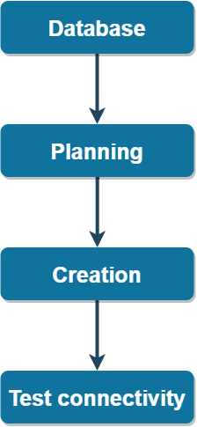
One of the key elements of our project is its data storage capabilities as this allow us to constantly store data on the plant as well as pull this data onto the website to present it in a graphical manner.
In order to accomplish this we will have to complete a set of tasks that will lead to the creation of a database that will hold data on the plants. More details will be given on the tasks in Section 6.2 of this document.

Figure 1: Work breakdown structure database

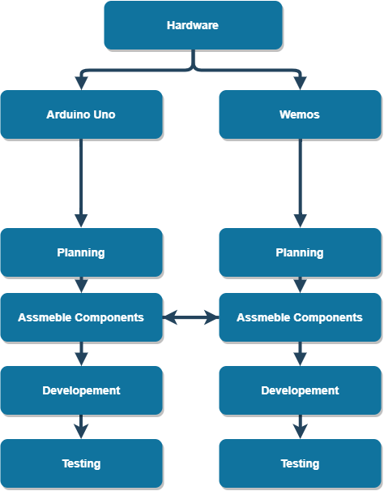

Figure 2: Work breakdown structure hardware

In order to be able to send data to the database we will also develop a device that will collect readings through sensors monitoring the plant and send the data to our database.
This will be done by assembling the device using two single-board microcontrollers, an Arduino UNO board and a WeMos D1 mini board, as well as a series of sensors. More on the assembly of this unit in Section 6.2.

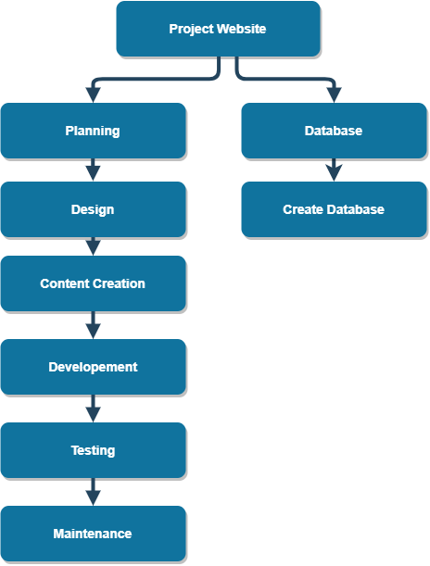

Figure 3: Work break down structure Website

The last integral component of the project is the website that will pull data from the database and showcase in an easy to read format that will include charts, graphs and tables.
We are going to use standard web development techniques to develop the web app as they suit our purposes on this occasion.

Assumptions and Constraints
During the development process, it was essential to make some assumptions and identify the constraints, as a full understanding and proper analysis of these parameters may decide the project a success or failure.
To begin with, the team leader took for granted access to the labs with all the equipment (Arduino boards, computers, plugins and wiring), Wi-Fi connection and database access.
Since Agile methodology heavily relies on the client engagement, it is crucial to consider all possible scenarios of the client’s involvement. The client is expected to be available 5 days a week in case of any enquiries related with the project, as well as play an active role throughout the planning, prototyping and development process. In addition, it is vital the client has, at least, a basic working knowledge of the technology implemented, so that they are aware of the project scale and costs related to the actions performed by the team. That, in turn, may be helpful to making the decision whether they can still afford it and whether the future production will still be profitable.
Another assumption is the fact that the requirements will not change over time and any modifications required will be simple to implement without causing significant delays in the development process.
Finally yet importantly, it is necessary that the client notify the team about any changes that need to be made as soon as possible, so that it does not cause significant complications, especially during the advanced development stage.
Regarding the team, project developers are expected to work on the project 8 hours a day, 5 days a week.
There are no staff rotations predicted within the project lifespan, what is vital to keep the development process going smoothly. Since the team members recruited for this task are considered to be focused and reliable, the project leader does not expect any significant delays, which will be also counteracted by organizing regular evaluation meetings.
However, every project, especially as complex as a Smart Eco System, has some constraints in place. In most of the cases, it is money and time; two types of currency, with one common theme - both need to be spent wisely.
Even the most accurate cost breakdown may leave out some costs, especially ‘emergency’ ones, when there is a need of making an unplanned purchase or other expenditure. In addition, delays caused by waiting for one part of the project to be completed, or by the absence of one of the team members, may influence the whole development process and end up exceeding the deadline.
Another constraint is the team working hours due to the limited hours of access to the laboratories. The team members have a host of other projects to complete in addition to this one, so the hours they can work on the project are limited. This also leads into the fact that the labs and their staff are only available during the day so access to the labs at hours that might have been more convenient for the team may not be feasible.

Detailed PROJECT PLAN

Product Breakdown Structure (a visual aid)

Figure 4: Product breakdown structure
In working on this project from start to finish we are going to produce documents, software and hardware that will be given to the client once the project has been completed. All the deliverables are shown above in Figure 4.
In terms of documentation we will deliver, a client pitch presentation which will serve the purpose of convincing the client that we are their best choice for achieving their desired goal. We will also deliver a project proposal document that will outline a vastly more detailed version of our plans to accomplish the clients vision, in comparison with the client pitch. After the project proposal has been delivered and full-scale development has started a white paper will be written and delivered to showcase the methods used to develop the final product. The final document delivered to the client will also be a concise yet detailed user manual that will contain instructions for the client on how to use and configure the devices as well as instructions for the users on how to use the devices.
The software and hardware that will be delivered to the client upon completion of the project will include: In terms of hardware, a device will be delivered which will contain an Arduino UNO with a WeMos D1 mini board and sensors attached to it. This is the device that will collect the data from the plant. In terms of software, a database will be set up on AWS that will have the ability to store the data collected by the hardware device. In addition to the database a website will be delivered that will have the ability to display the data collected in a graphical format.

Activity Plan (a visual aid)
Figure 5: General activity plan diagram
Figure 5
To create a project of this size

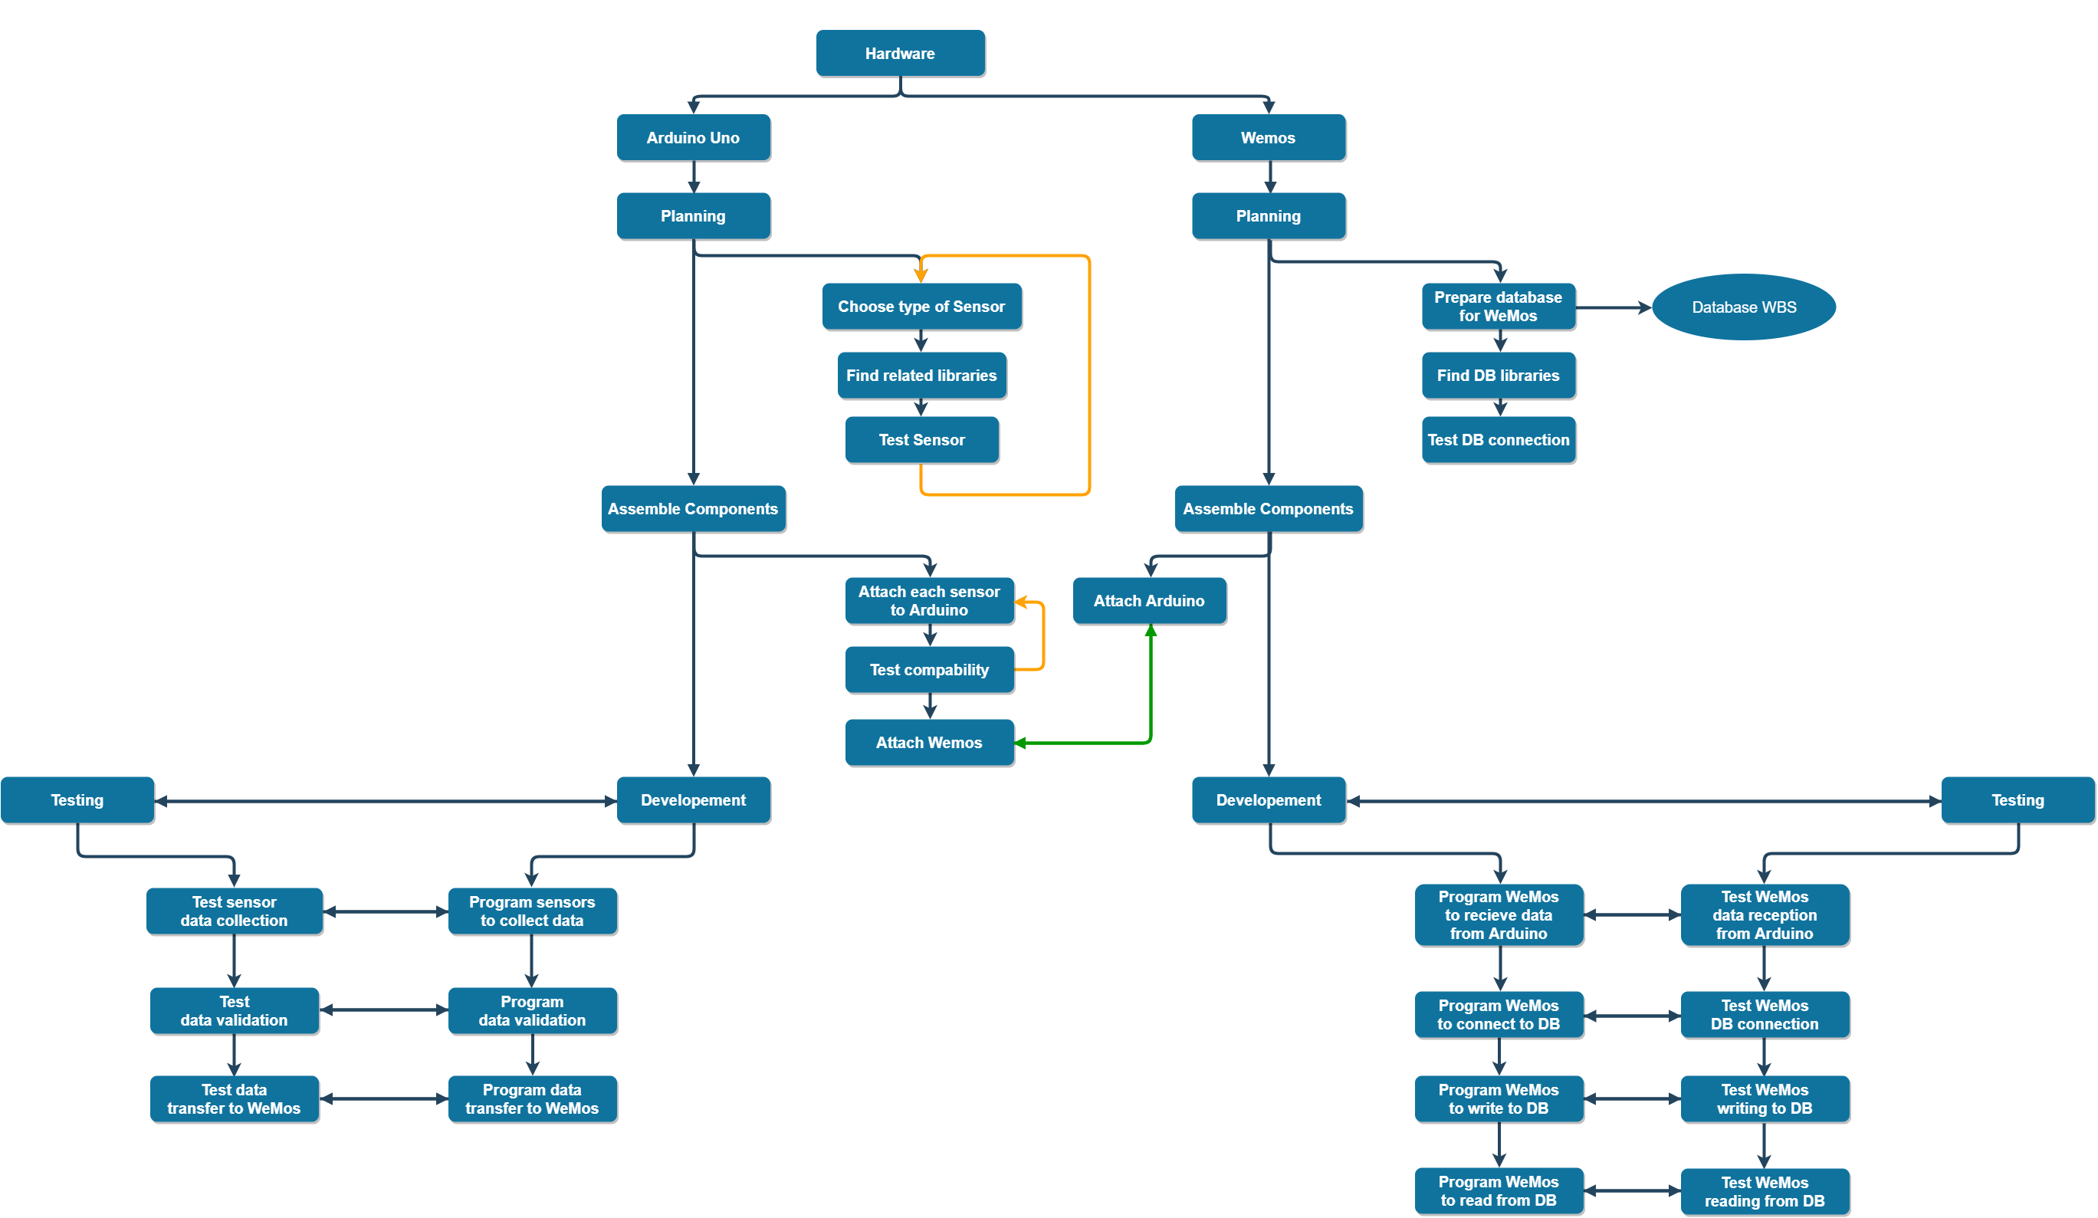
Figure 6: Activity plan diagram hardware
Figure 6
In order to deliver a device which will be able to perform all the functions we have outlined in this document we are going to have to perform activities in a concurrent manner for both the Arduino UNO and the WeMos. By doing this we are able to follow the efficient ideology of Agile Development which promotes working on multiple functionalities of a project simultaneously. When developing the hardware, we started working on the two devices simultaneously by planning and installing the additional components that each board will need to perform its functionalities. For the Arduino this meant selecting a sensor that will be used and installing the libraries it will need to work. Once that was done the sensor was test to make sure the readings it collected were accurate and in the correct format. For the WeMos this planning phase was only executed once as once the database connection had been established no further planning was required as the Arduino which will be connected to the WeMos will already have been planned. The actual planning stage for the WeMos will consist of preparing the database for connection which will be taken care of through a DBMS, then installing the software library that allows for database connection, and finally testing the connection between the WeMos and the database.
For the assembly of the components to create the device it was necessary to complete the assembly of the Arduino UNO before attaching the two boards to each other. In order to complete the assembly of the device a sensor will be connected to the Arduino UNO, it will then be test to ensure that it works once attached, this process will be repeated until all the sensors are attached. Once the process of attaching the sensors to the Arduino UNO is completed the WeMos and UNO will be attached to each other using all the appropriate wires.
The development phase will take the most amount of time as it will consist of programming the two boards simultaneously so that they can perform the overall function of collecting readings and putting them into a database. For the Arduino this will mean programming the board to read data through a sensor and validate the data collected before transferring the data to the WeMos board. The WeMos in turn will be programmed to receive the data from the Arduino UNO, it will then need to be programmed to be able to connect to the database. After that has been successfully accomplished the board will have to be programmed to write to the database to put data it has received from the UNO into the database.
The testing phase will be carried out alongside development as the code written to achieve all the functions mentioned in the development phase will be executed to observe if it performs the desired functionality.
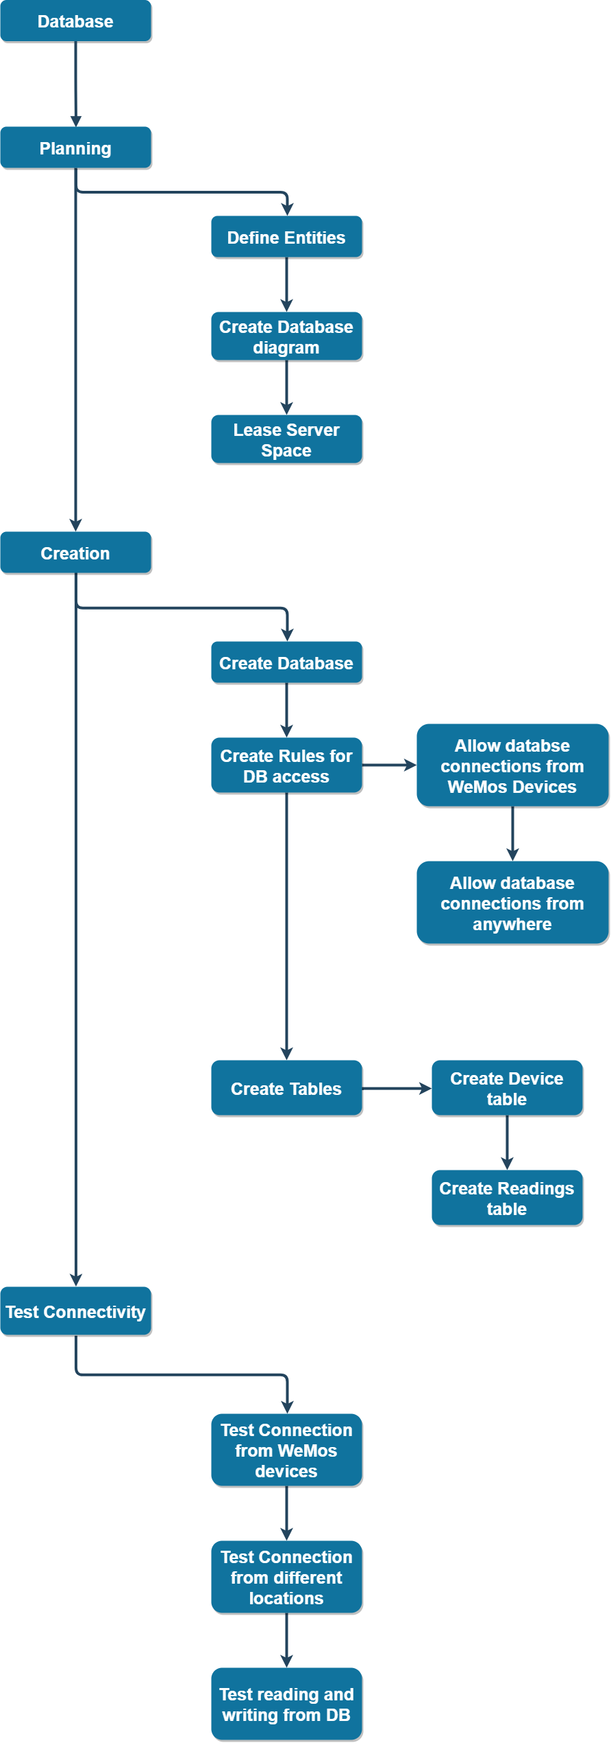
Figure 7: Activity plan diagram database
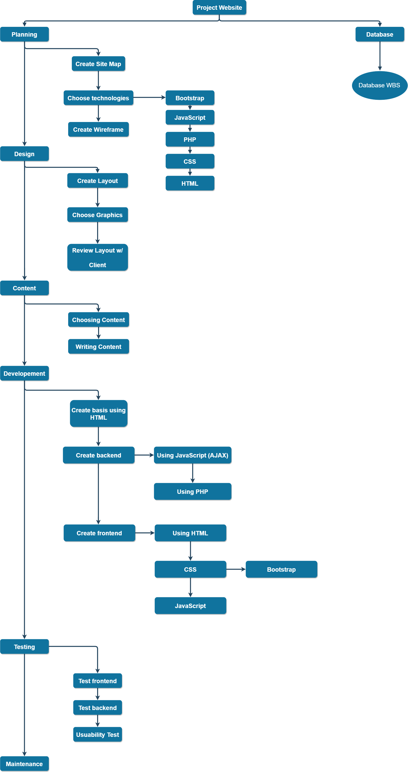
Figure 8: Activity plan diagram Website

Resource Allocation and Timeline
[Insert a resource plan (some visualization, e.g. Gantt chart).]

Identification of Critical Path
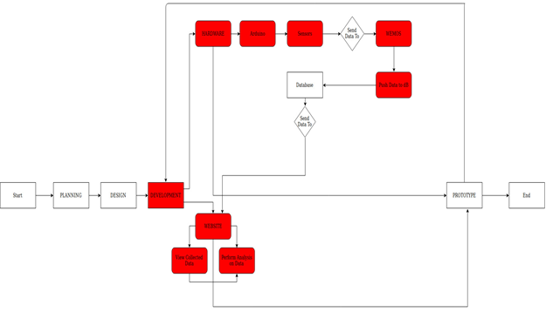

As we have adopted an Agile development methodology, the work is broken down into ‘chunks’ which often run concurrently, which makes identifying a critical path slightly more difficult. In other words, work on the website and hardware sections of the project may be happening simultaneously, as opposed to sequentially as in the Waterfall methodology. However, a part of the Agile process is utilizing SCRUMs, short bursts of work on a particular iteration or section of the project. During the Development phase of the project, we can find our Critical Path. Provided the preceding Planning and Design phase have been completed to a satisfactory level, the Development phase is critical to the completion of the project and is where the bulk of the work will be located. The website will be built at the same time as the hardware is being put together. Both rely on the database, which will already be in place as it will have been designed and implemented in a previous phase of the project.

Identification of Costs and Benefits
Since the project involves a significant amount of investment, it is necessary to identify the costs, that are or will be generated not only by the product alone, but also by the development and production process, as well as outline the benefits to be gained. It is vital to undertake an economic analysis that will help determine whether the project has an acceptable return. By performing Cost - Benefit Analysis (CBA), the client will be provided with the estimation of the net benefits associated with achieving defined goals.
To start with, generated costs may be divided into different categories, depending on the factors taken into consideration. Firstly, the venture will consist of both short and long-term expenses. The former, considering a year as a short term, includes all liabilities related with delivering the final product. These are necessary tools and equipment, prototypes and their alternatives, the Arduino and Wemos boards required for the production process as well as training provided to all members of staff by the manager or other person assigned to this task. In addition, Abertay Plant System may have to consider a purchase of assembly line equipment and land, which will be used for to create a production hall. The latter, in turn, means expenses such as electricity bills, fees for using the database, wages for a maintenance team, that will ensure the production goes smoothly and without any major problems, as well as reordering the assembly line parts that will replace the broken ones.
In addition, every CBA requires determining the fixed and variable costs that are considered time-related business expenses dependent on the level of goods or services produced by the business. However, the only costs that will grow or decrease depending on the sales are bills and database rental. This makes the estimation of the potential expenses and the calculation of the return rate significantly easier.
In terms of direct costs (directly associated with the production of goods and services) and indirect costs, they will mostly overlap with fixed and variable costs. However, an exception is made for the software licenses required for Arduino and Wemos boards as they are open-source and available free of charge.
Finally yet importantly, the raw materials going directly into producing the products are only part of the Abertay Plant System’s financial consideration. As happens in many cases, the labour cost may surpass the cost of direct materials; therefore, it is vital to adjust the staff numbers and their roles to the company’s needs. Regarding the company’s anticipated growth, this category may not only include staff wages, but also advertising and employing a non-executive director, who will act in the interest of the stakeholders.
Provided that professional advertising will be implemented and the company is prepared for any potential changes in technology, the product will have an opportunity of becoming a bestseller in both the IoT and gardening markets. That, in turn, would be the biggest benefit in itself, as any increase in the product’s sales would be reflected in the increased profits for the manufacturer.
In addition, there is an intangible asset that is at least equally important for any business – reputation. As it represents a general opinion about the company, its policies, innovation and the attitude toward its customers, it often dictates the sales and hence cannot be ignored under any circumstances. Taking the opportunity of launching a new product gives the business a chance to reach a broader group of consumers. A product such as Smart Eco System attracts business with not only its fresh idea, but also its practicality and responsiveness.
Going forward, Abertay Plant System may take advantage of their bespoke system and use it for other applications, such as modifying the device to monitor plants in other commercial and industrial environments.

Justification of Project Approach & Project Methodology
Concerning the project approach, we decided to follow the Scrum methodology. This was decided after analyzing the projects size, complexity, and the deadline set by the client. The decision to follow Scrum was also because we had a limited amount of information on the projects requirements and on what we were expected to deliver by the end of development time. The size of the project meant that a lot of work would have to be carried out to make sure that both the documentation and the final product are completed on time. However, due to our limited knowledge of the scope and requirements of the project we could not create a plan that would encompass everything that needed to be done to deliver a complete project. Scrum was ideal for our case as we could arrange a meeting and work on the documentation or develop the system every time we gained new information about the project. The Scrum manifesto also heavily involves the client in the process as they are incrementally being presented with prototypes of the system and the set of requirements we have derived from the client’s specifications. This is a very big benefit to us, as it allowed the client to monitor the current state of the prototype system provided to them and get feedback on what they want us to develop further.
Another advantage of Scrum is that components and features can be rolled back or re-examined with relative ease if the client is unsatisfied with the requirements we have extrapolated from our meetings or the prototype delivered is unsatisfactory. Moreover, using the approach of Scrum allows for work to be carried out on multiple fronts concurrently, meaning that work will be completed on various components simultaneously i.e. a prototype of the device can be created by some members of the team while other members work on the white paper. In addition, since our project is made up of multiple parts (the device, the website and the database) that will have to work in unison to deliver an optimal user experience, it was essential to work on the various parts simultaneously.
Another software development methodology that is popular but we chose not to adopt, is the Waterfall method. Waterfall relies heavily on a plan that details all of the tasks, components and features and when they need to be delivered or completed. This would not fit either our team structure or our schedules, as the project cannot be worked on constantly due to other commitments. This would also be a problem seeing as how we did not know about all the aspects of the projects when we undertook the project, thus making it impossible to create the all-important Waterfall plan. The Waterfall methodology also does not adapt easily to change, which in cases where the development team knows all the aspects that need to be designed and created is ideal. In other cases where knowledge of the full scope of the project is not possible, the need for change would hinder the project massively. The Waterfall method also relies on a Project Manager to set out the plan as well as to coordinate the team working on the project. Our team size and structure did not allow for the appointment of a Project Manager, thus it would be difficult to adhere to a rigid Waterfall plan. The Waterfall methodology also measures success based on conformity to the plan and completion of iterative stages in the manner that was set out in the plan. While there is nothing inherently wrong with this approach, after discussing this among our team, we decided that this would not be very conducive to the way our team members work. We concluded that the way we normally complete work was looking at a list of features we need to complete and trying to create the feature or component in any way possible and refining it after it was functional. It is fair to say that this ideology is at the heart of the Scrum methodology.
The Spiral software development methodology was also considered, but was not chosen due to its risk-driven approach to development as well as the fact that it also follows an incremental approach much like Waterfall. The process of identifying risks and planning work that needs to be done in an incremental manner is, as mentioned above, not conducive to the way the team works, firstly because it is incremental and secondly because the risks that we have identified in our project are easily mitigatable as well as inherent to all projects of this size. The Spiral methodology also breaks down the work needed into four phases that are executed on different levels within the spiral with the team working their way down the levels till they reach the “final” level, which tends to be the harder or more complex parts of the project. Due to the nature of our project that needs all the different components to work together to be operational, it would not be feasible to break down tasks based on risk and difficulty and complete them in such an order. Another aspect of Spiral methodology is that the management structure is often complex, due to the fact that the management has to control the teams transitions from one phase to the next many times over, as the development “follows” the Spiral. Once again, the size and structure of our team would not allow for the appointment of dedicated management staff. The biggest factor in not adopting Spiral methodology was the fact that the schedule for Spiral can be unknown since the work is completed cyclically. This would cause an issue in our case seeing as we have a hard-set deadline that we had to meet.

Version Control and Requirements Changes
Regular version control combined with proper approach to the requirements changes is key to meeting deadlines. The team working on the Smart Eco System decided to take advantage of an existing version control system – the online and open-source platform, GitHub. All the documents, as well as the code used to set up the Arduino and Wemos boards have proper descriptions assigned and are being stored in a separate folders. In this way when a change is made it is visible to all team members. In addition, GitHub allows users to view previous versions of their projects, which is integral when it is found that some piece of code is missing or it is necessary to roll back to a backup copy and compare changes made.
Moreover, the tasks assigned to the team members are managed online at trello.com, where a special shared Kanban board has been created. The above-mentioned platform is highly useful for the project manager, as they are able to check the progress at any time. It is also useful as it allows team members to track the work they have done as well as what work they still need to complete and have been assigned. This is most evident when a team member finishes some work assigned to them, they do not have to wait for the project manager or team leader to see what other tasks they are supposed to complete. Moreover, since Trello has the option to add a deadline to the card (task) it does not only serve as a kind of schedule, but also motivates to focus on submitting the work on time, as every delay is visible to the leader.
Regarding the team response to the requirements changes, there were several steps undertaken to keep the development process operating smoothly. Firstly, every sprint (set of tasks, also called stories, which were planned to be executed within certain amount of time) begins with the mandatory meeting between both sides – the client and the team. The discussions are vital because two out of three variables that determine the story - scope and importance - depend on the product owner opinion. In addition, during the meetings, the client will inform us of their expectations, this will allow the team to clarify the requirements and be able to more accurately develop what the client had in mind.
However, as the requirements changes are inevitable and may happen at any time during development. These changes and the processes that will be used to implement them must be kept separate from the main on-going project tasks since even the smallest snowball may begin an avalanche, and neither the client nor the development team would like to take this risk.
Since the project is expected to join the group of 34% of the IT projects, that were completed on time and within the budget (according to the Standish Group), it would be irresponsible not to take advantage of the online communication and collaboration tools. Web conferences are an invaluable tool for any company; they are not only cheaper than any meeting and phone calls but enable overcoming obstacles before they develop into major issues.
Moreover, in order to improve the actions taken, there will be a special Change Log kept by the project leader. That will not only facilitate tracking them but will also outline how the requests affect the scope and how they will be handled. The changes will then be filtered by priority and finally, if considered appropriate and approved by the team leader, they will be implemented.

Quality Assurance and Test Plan
In order to evaluate if the project will be successful, the quality of the product must be seen to meet the required standards. This will be an ongoing process throughout the project lifespan, aided by the Agile Development Methodology adopted by the project team. This enables the quality of the project to be evaluated on a frequent basis, which in turn should ensure that the software produced is of a high standard. It is fair to say that the project can be broken down into three major parts, namely the Arduino and peripherals, the database and the website. Quality assurance will need to take place over each of these parts to ensure they are all operating at the required standard. The Arduino and the peripherals connected to it are on the frontline of the project; they need to be reliable and operate effectively without supervision. They also need to provide accurate data without overlap. For example, the moisture sensor should monitor only the moisture level of the soil and not, say, the amount of light the plant is receiving. The data collected by the sensors also needs to be categorized and stored in a logical fashion. Using the moisture sensor example again, it makes sense to store and show this value as a percentage rather than a rating in calories. The WeMos unit provides internet connectivity for the whole Arduino sub-system and this is a critical factor in providing accurate information to the user. If the WeMos cannot connect to the internet, then it cannot send the data to the database, which in turn cannot be accessed by the website. Therefore, the WeMos should communicate the lack of internet connectivity to the Arduino board, which can provide a visual or audio alert to the user. A failure in some part of the Arduino sub-system can have a massive ‘domino-effect’ on the rest of the project, so it is vital that the quality of the components and the output is of as high a standard as is reasonable to expect.
The database is the intermediary between the Arduino sub-system and the website. Its main purpose is storing data. The tables within the database should be designed to accept only pre-defined datatypes and store this data in a logical manner. The data held in the database is then accessed by the website, showing the user the current or historical status of the plant. If the database is provided with high quality data and the tables are designed in such a way to make accessing this data easy, the quality of the database cannot be questioned.
The website will be the users’ main interface with the product and this perhaps places greater emphasis on the quality assurance involved. With the Arduino sub-system and the database, the quality is mainly measured by the operational effectiveness of each part. However, the website is required to not only be functional, but attractive to look at, easy to navigate and simple to comprehend. Clearly, the quality of each of these aspects will need to be closely monitored and evaluated to make sure they all reach the required level of satisfaction. For example, it would be counter-productive to have the website access a large amount of data and then display it in a manner that does not make sense or is not helpful to the user. It is fair to say that the website section of the project requires both functional quality assurance and cosmetic quality assurance. They are both equally important, but assessed in different ways. The quality of the website will be ascertained via rigorous testing, of which will be discussed in the following section.
To gauge the quality of our project, significant testing will take place to ensure that inputs are producing the correct outputs, data is stored in the correct format and grouped together in the appropriate tables and that this data is displayed correctly via the website and provides useful insights to the user. Doing such rigorous testing should make any errors apparent and strategies can be devised to correct them. Even before the development cycle begins, testing will be in place in the form of design reviews. These will be reviews of the paper based diagrams, wireframes and pseudocode and will require the whole team to sign off on whether they meet the requirements or not. Whilst this will not catch every error or take into account every use case, it will at least eliminate any basic logic errors in the design of the system. If an accurate representation of the system can be produced using pen and paper, not only can this be tested but it will also provide an all-encompassing frame of reference during the development phase.
Similar to the design review, all code written will be subject to a peer review before it is implemented in the system. This will help find any syntax or logic errors before deployment as well as foster a greater sense of collaboration as team members will have to work together to solve any problems that arise. Code reviews will also provide multiple solutions to the same problem, meaning that the most effective can be selected and implemented.
In order to test the system before deployment, a variety of methods will be implemented. The first area to test will be communication between the Arduino sub-system and the internet. A rotary switch will be used in place of the environmental sensors to check that data from the switch is interpreted correctly by the Arduino, pushed to the WeMos and registers in the Arduino IDE. This data will then be sent to the database to ensure that it is stored in the correct table and the correct format. To display this data on the website, a preliminary PHP script will be written to ensure that data can be displayed in a basic webpage. This will be a simple process and is designed to ensure that data from the sensors reaches the end goal of being displayed online. More advanced testing will see the rotary switch replaced by one of the sensors and replicating the same process, leading up to all sensors being attached to the Arduino and ensuring that the same result is achieved. Only after this very basic testing of the overall system has been carried out will the complexity be increased. This helps set a baseline of the systems operation that can be built upon and should aid in debugging the system as a whole should an error emerge.
The website will also have to undergo extensive usability testing to ensure that it is attractive to users, easy to navigate and displays the relevant information selected by the user. Whilst the backend code will be tested via unit testing, the frontend will rely on usability surveys to ascertain what is effective and what requires further development. These are perhaps the most important tests to run, as the whole system could operate perfectly but this becomes a moot point should the website itself be hard to use or cumbersome to navigate.
It will also be worthwhile conducting usability testing on the hardware and the user manual, as the user is required to set up the system independently. As developers, we know how the system should be set up intrinsically. The same cannot be said for consumers of the product however. Despite the system being designed to be as simple as possible, the user manual produced should be exhaustive in regards to describing each part of the system, what it does, where and how it is used and how to troubleshoot commonly occurring problems. Similar testing to the website will be carried out to ensure smooth operation of the system.

Risk Management Plan
In order to ascertain the risks that may arise over the course of the project, a risk matrix was produced to identify the most likely risks. This is a useful visual aid to determine the events that could potentially have the biggest negative impact on the project. Each risk event is given an ID number, the risk is described and then values are assigned to each event to determine the probability (given as a percentage), impact (rated on a scale of 1 - 5) and priority of the risk (Probability multiplied by Impact). A brief example of how the risk could be mitigated is then provided. The matrix is as follows:

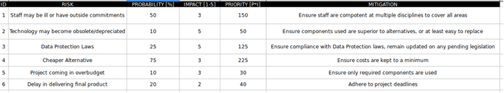
Drawing from this matrix, we gain an understanding of how each event could influence the project and can plan accordingly to mitigate the risk of each event occurring. It is now worth looking at each risk in more detail so that they can be fully explained in terms of their probability and impact.
The first risk identified in the matrix is that staff may be unavailable for whatever reason. The probability of this occurring is 50%, as either staff will be available or they will not. The impact is given a score of three, as it is a medium level risk. The priority score works out at 150, placing it as the second biggest overall risk to the project. This is a fair assessment as the team is made up of only three individuals, so losing one individual results in a 33% loss in productivity. In order to mitigate this risk, it is vital regular progress and evaluation meetings are held to ensure that any work being carried out is on target to meet set deadlines. They are also useful to track progress not only of the overall project, but each section as the Agile methodology adopted for the project allows for concurrent working practices. Staff are also competent in multiple disciplines, so any shortfall in one area should easily be covered. This might delay progress in one area slightly, but this is compensated by the fact that the overall project should stay on track.
The second risk identified in the matrix is that the technology used in the project may become obsolete or depreciated. The probability of this occurring is 10%, as the most contemporary hardware and software is being implemented in the project. The impact is given a score of five, as it is a high-level risk that could potentially derail the project. The priority score works out at 50, placing it as a low risk to the project. This is accurate as extensive research was conducted to ensure that all technologies used in the project had a very low chance of becoming obsolete in the project time span. To mitigate this risk, the most superior hardware components and software developments techniques are being used to ensure that the device has a long life span in terms of the technologies it is made up of. The device has also been designed to be as simple as possible whilst still ensuring maximum functionality. Breaking down the device into its component parts, one can see that it is little more than a micro-controller circuit board, a variety of sensors, a database and a website. This has led to the system being inherently modular; that is to say, should one part require updating or replacing, it should be a simple process to swap the redundant component out and integrate a new component without adversely effecting functionality. This also means that the overall system can be updated should newer technologies become available, increasing the lifespan of the device indefinitely.
The third risk is identified as Data Protection Laws being amended to incorporate more stringent conditions that may affect the project. The probability of this occurring is 25% as these laws are constantly evolving to meet contemporary demands for securing data. Currently, there are no plans to hold personal or sensitive data in the system, which current Data Protection Laws seek to protect. However, the system has the ability to potentially store personal data and Data Protection Laws could potentially change to incorporate protection of any data stored on a remote database. Therefore, this could have a massive impact on the project, justifying the impact score of five. This gives the risk a priority score of 125, placing it as the second least likely risk to the project. The impact of this risk should not be underestimated however, so it is essential that current and any forthcoming Data Protection Laws are adhered to in order to mitigate any negative effects.
The last major risk identified in the matrix is a competitor creating a cheaper solution. The probability of this occurring has been scored at 75%, as out of the alternatives researched, the solution proposed by the team is dramatically cheaper to those currently available. This means there is room in the market for a system that undercuts those currently available and we as a team have to assume that we are not the only development team that have realized this fact. This has been given an impact score of three, as if a competitor does produce a cheaper solution, it should be easy to ascertain how they produced a cheaper system and this can then be incorporated into the current project. The priority score of 225 makes this the biggest risk to the project. To mitigate this risk, only the components that are required will be integrated to keep costs as low as possible. This does not mean that the lowest priced component will be automatically chosen for implementation in the system, rather the chosen components will all provide value for money and (where possible) be versatile in their operation.
There are two other risks identified in the matrix, namely the project coming in over budget or there being a delay in delivery of the final product. Whilst both these risks do not necessarily mean that the project will fail, they can both potentially lead to the client losing faith in the team, meaning that further development or opportunities may be impacted. Whilst both risks have a low probability and low impact score, they are important to consider as a positive working relationship between the client and the team is essential for a successful project.

References
Arduino.cc. (2018). Arduino - Home. [online] Available at: https://www.arduino.cc/ [Accessed 20 Sep. 2018].

Foundation, R. (2018). Raspberry Pi — Teach, Learn, and Make with Raspberry Pi. [online] Raspberry Pi. Available at: https://www.raspberrypi.org/ [Accessed 20 Nov. 2018].

Gill, R. (2016). Plant Monitoring System. [online] Hackster.io. Available at: https://www.hackster.io/ryanjgill2/plant-monitoring-system-88ed2b [Accessed 11 Oct. 2018].

SwitchDoc Labs. (2018). SmartPlantPi - Raspberry Pi based Smart Plant Kit - No Soldering!. [online] Available at: https://shop.switchdoc.com/products/smartplantpi-raspberry-pi-based-smart-plant-kit-no-soldering [Accessed 11 Oct. 2018].

Instructables.com. (2018). Easiest Arduino Smart Plant Watering. [online] Available at: https://www.instructables.com/id/Easiest-Arduino-Smart-Plant-Watering/ [Accessed 11 Oct. 2018].

Appendix A: Approval
The undersigned acknowledge that they have reviewed the <Project Name> Project Proposal and agree with the information presented within this document. Changes to this document will be coordinated with, and approved by, the undersigned, or their designated representatives.
[List the individuals whose signatures are desired. Here, team members, clients etc. should be listed. Add additional lines for signatures as necessary. This form should be signed and scanned into the document. NOTE: You need to get a real signature from the client, so make sure you get this in due course so you can submit the proposal.]

Signature Team Member: |  | Date:
Print Name:
Role:

Signature Team Member: |  | Date:
Print Name:
Title:
Role:

Signature Team Member: |  | Date:
Print Name:
Title:
Role:

Signature Team Member: |  | Date:
Print Name:
Title:
Role:

Signature Team Member: |  | Date:
Print Name:
Title:
Role:

Signature Client: |  | Date:
Print Name:
Title:
Role:

Appendix B: Key Terms

The following table provides definitions and explanations for terms and acronyms relevant to the content presented within this document.
Term | Definition
IoT | Internet of Things: network of physical devices, vehicles, home appliances, and other items embedded with electronics, software, sensors, actuators, and connectivity which enables these things to connect, collect and exchange data
Arduino Uno | Microcontroller board providing all the circuitry required for a control task
WeMos D1 Mini | A mini board allowing for WiFi connectivity
IT | Information Technology
CEO | Chief Executive Officer
GDPR | General Data Protection Regulation
Open Source | A type of computer software in which source code is released under a license in which the copyright holder grants users the rights to study, change, and distribute the software to anyone and for any purpose. Can also apply to hardware
European Union Public License | A free software license created and approved by the European Commission
Ardunio Privacy Policy | A policy regarding how Arduino collects and processes personal data collected when using it’s systems
Amazon Web Services | A subsidiary of Amazon.com that provides on-demand cloud computing platforms to individuals, companies and governments, on a paid subscription basis
Kanban | A method to manage and improve work across human systems
Kanban Boards | A tool used to implement Kanban; essentially a pinboard that can track progress of sub-tasks within the project
Trello | A digital workspace for implementing Kanban Boards
Wi-Fi | Wireless-Fidelity: allows for wirless internet connectivity
Agile | A software development approach under which requirements and solutions evolve through the collaborative effort of self-organizing and cross-functional teams and their customer/end user
Scrum | An Agile framework for managing work with an emphasis on software development
Waterfall | A sequential design approach
Spiral | A risk-driven design approach
IDE | Integrated Development Environment: Asoftware application that provides comprehensive facilities to computer programmers for software development
PHP | A popular general-purpose scripting language that is especially suited to web development
DBMS | Database Management System

Appendix C: Team Rules and Roles

Team Roles
Dorota Marczak – Team Leader
Nader Sobhi – Application Developer, Keeper of Minutes
Scott Allan – Application Developer

Team Rules
Decision Making – Options put to a vote. Option with the most votes is chosen and developed further. Objections are noted and back-up plan formulated.

Disagreements – If disagreements between team members occur, a mediator will be appointed to listen to the views of both sides. The mediator will then weigh up both arguments and propose a solution that will benefit the team as a whole rather than the individual.

Absences – The absentee must inform the team as soon as possible of the planned length of their absence. Willingness to undertake work at home is viewed in a positive light and no sanctions will be placed on the individual. Failure to inform the team of an absence or reluctance to complete work at home will result in a mutually agreed sanction on the individual to be determined on a case by case basis.

Breakdown of Work – Team members are free to chose which section they wish to work on, based on a ‘first come, first served’ basis.

Completion of Work – A section of work cannot be said to be completed until it is signed off by at least one other team member, ideally the project leader.

Appendix D: Minutes & Reflection
Meeting One
Date:
20th September 2018

Time:
10am

Venue:
Room 4506, Kydd Building, Abertay University

Attended By:
Dorota Marczak, Nader Sobhi, Scott Allan & Declan Bell

Absences & Apologies:
N/A

Review Previous Minutes:
N/A

Topics of Discussion:
Initial discussion on how we want to approach the project in regards to the requirements set out. Investigation into the technologies, both software and hardware, that could be implemented to meet requirements. Research into currently available devices and how these could be improved or adapted to meet our needs. Development methodologies researched to find best fit for team and project.
Software, hardware & development methodology agreed upon and team leader appointed.
Preliminary work on basic prototype to test aspects of functionality and connectivity.

Challenges:
The main challenge raised was in regards to how we would collect, store and display pertinent data, as well as how communication between the technologies would be achieved. It was decided to build a basic functioning prototype to address these concerns.

Actions for Next Meeting:
Complete work on basic prototype
Begin work Executive Summary and the Introduction section of Project Proposal

Next Meeting Details:
27th September, 10am, Room 4506, Kydd Building, Abertay University

Meeting Two
Date: 27th September 2018

Time: 10am

Venue: Room 4506, Kydd Building, Abertay University

Attended By:
Dorota Marczak, Nader Sobhi, Scott Allan & Declan Bell

Absences & Apologies:
N/A

Review Previous Minutes:
Previous minutes were discussed to clarify scope of project and the technologies to be used.

Topics of Discussion:
Executive Summary was discussed in terms of how to make it an effective overview of the project as a whole. It was decided it was important to convey all the important information in a concise and logical manner that would then be expanded upon throughout the proposal.
Preliminary work on the main body of the proposal also began, with the intention that the Introduction section would be completed before the next meeting.

Challenges:
The main challenge raised was how to make the Executive Summary informative whilst still being concise. This was addressed by agreeing to refer back to it and adapt the Executive Summary where required as work on the proposal progressed.

Actions for Next Meeting:
Completion of Introduction section, begin work on Project Description

Next Meeting Details:
4th October 2018, Room 4506, Kydd Building, Abertay University

Meeting Three
Date:
4th October 2018

Time:
10am

Venue:
Room 4506, Kydd Building, Abertay University

Attended By:
Dorota Marczak, Nader Sobhi, Scott Allan & Declan Bell

Absences & Apologies:
N/A

Review Previous Minutes:
Previous minutes were reviewed to ensure that all work stated to be completed was done so and ensure that everyone was managing with the workload.

Topics of Discussion:
Risks involved in the project.
The needs of the client and how they would be addressed.
Identification of stakeholders.
Identification of short-term, long-term and operational goals.

Challenges:
The main challenge was devising the risks associated with the project, how they would apply to the project and what we could do to mitigate their effect.

Actions for Next Meeting:
Research and review alternative solutions already in the marketplace.

Next Meeting Details:
11th October, Room 4506, Kydd Building, Abertay University

Meeting Four
Date:
11th October, Room 4506, Kydd Building, Abertay University

Time:
10am

Venue:
Room 4506, Kydd Building, Abertay University

Attended By:
Dorota Marczak, Nader Sobhi, Scott Allan & Declan Bell

Absences & Apologies:
N/A

Review Previous Minutes:
Topics covered in last meeting were discussed to ensure everything was described accurately.

Topics of Discussion:
How the project would impact the clients working practices, what changes they may need to make to their operations & how the project would benefit the client.
Alternative solutions/devices already available were discussed and their strengths and weaknesses identified.

Challenges:
The main concern was in regards to existing devices and how we could improve upon them. It was agreed that it was possible to provide a cheaper solution that retained important functional aspects without being overly complex to produce or use.

Actions for Next Meeting:
Produce all the graphs and diagrams needed for the proposal.

Next Meeting Details:
18th October 2018, Room 4506, Kydd Building, Abertay University

Meeting Five
Date:
18th October 2018

Time:
10am

Venue:
Room 4506, Kydd Building, Abertay University

Attended By:
Dorota Marczak, Nader Sobhi & Scott Allan

Absences & Apologies:
Declan Bell – No reason given

Review Previous Minutes:
Currently available devices were reviewed again so that we could incorporate the strengths of each into the project, whilst ensuring we did not build in the same weaknesses.

Topics of Discussion:
How to allocate resources in regards to hardware, software and team members time.
How the work would be broken down into distinct sections so that work can be carried out concurrently.
Identification of the critical path.
How all of the above would be best represented in terms of diagrams, charts, etc.

Challenges:
The main challenge was reallocating work to cover for Declan’s absence whilst ensuring no one was overburdened

Actions for Next Meeting:
Develop a risk management plan.
Justify the approach to the project as well as the project methodology adopted
Ascertain what we can assume in regards to resources being available as well as review what constraints may impact the project.

Next Meeting Details:
1st November 2018, Room 2022, Old College Building, Abertay University

Meeting Six
Date:
1st November 2018

Time:
10am

Venue:
Room 2022, Old College Building, Abertay University

Attended By:
Dorota Marczak, Nader Sobhi & Scott Allan

Absences & Apologies:
Declan Bell – No reason given

Review Previous Minutes:
Work breakdown structures and resource allocation were reviewed to ensure all aspects of the project were covered and an individuals workload was not over bearing.

Topics of Discussion:
Risks posed to the project and how they could be mitigated and how we could represent this information in a risk matrix.
Why the methodology adopted was appropriate and justification of the approach to the project.
What we could assume in regards to project resources being available and what potential constraints could impact the project.

Challenges:
The main challenge was reallocating work to cover for Declan’s continued absence whilst ensuring no one was overburdened.

Actions for Next Meeting:
Justify version control platform chosen.
Update appendices.
Read over document to ensure it is clear, concise and contains the required information.
Get client to sign off proposal.

Next Meeting Details:
5th November 2018, Room 2022, Old College Building, Abertay University

Meeting Seven
Date:
5th November 2018

Time:
10am

Venue:
Room 2022, Old College Building, Abertay University

Attended By:
Dorota Marczak, Nader Sobhi & Scott Allan

Absences & Apologies:
Declan Bell – No reason given

Review Previous Minutes:
Work completed at last meeting was reviewed to ensure it met the appropriate standard.

Topics of Discussion:
Proposal was reviewed by each team member to ensure that all sections contained the appropriate information and was conveyed in a logical manner.

Challenges:
Ensuring all aspects of the project were described accurately whilst staying within the word count.

Actions for Next Meeting:
Continue reviewing proposal as a whole and updated appendices where required.

Next Meeting Details:
6th November 2018, Room 2022, Old College Building, Abertay University

Meeting Eight
Date:
6th November 2018

Time:
10am

Venue:
Room 2022, Old College Building, Abertay University

Attended By:
Dorota Marczak, Nader Sobhi & Scott Allan

Absences & Apologies:
Declan Bell – No reason given

Review Previous Minutes:
Any inconsistencies noted from last meeting were reviewed to ensure compliance

Topics of Discussion:
Continued review of the proposal overall

Challenges:
The General Activity Plan Diagram and Resource Allocation Gantt Chart were deemed to be inadequate and required further refinement.
Actions for Next Meeting:
Continue reviewing proposal as a whole and updated appendices where required.

Next Meeting Details:
7th November 2018, Room 2022, Old College Building, Abertay University

Meeting Nine
Date:
7th November 2018

Time:
10am

Venue:
Room 2022, Old College Building, Abertay University

Attended By:
Dorota Marczak, Nader Sobhi & Scott Allan

Absences & Apologies:
Declan Bell – No reason given

Review Previous Minutes:
Any inconsistencies noted from last meeting were reviewed to ensure compliance.

Topics of Discussion:
Continued review of the proposal overall.

Challenges:
The proposal was found to be formatted inconsistently and required work to ensure it was presented in a uniform manner.

Actions for Next Meeting:
Continue reviewing proposal as a whole and updated appendices where required.

Next Meeting Details:
8th November 2018, Room 2022, Old College Building, Abertay University

Team Reflection

Appendix E: Peer Assessment

Name (print) for each team member (including yourself) | Each team member should individually and confidentially upload this form to BlackBoard, using the ‘Peer Assessment’ link in Blackboard (via ‘Submit Module Assessment and Deliverables under Assessment information). Each team member should select a mark from 0, 0.5, 1, 1.5, 2, 2.5, 3, 3.5, 4, 4.5 to indicate how well they think the other team members have contributed to the TEAM WORK (you also give a mark for your own contribution to the project to yourself).

Appendix F: Artefact or prototype material

[This section can contain preliminary work, e.g. website pages prototypes, code, a selection of tools, images of displays etc.
]

